Dear Second Grade Families,

Welcome to the 2020-2021 school year at Cyber Academy of South Carolina! Second grade is full of fun and learning adventures. We cannot wait to watch you learn and grow over the next year!

Mrs. James will be your second grade ELA teacher this year and Mrs. Calixte will be your second grade math teacher. However, Mrs. Calixte is out on maternity leave right now with her sweet baby boy! She will be back soon. Be on the lookout for more important information from us via email.

In the meantime, see below to learn more about us! We cannot wait to get to know all of you!

Sincerely,
Mrs. James & Mrs. Calixte

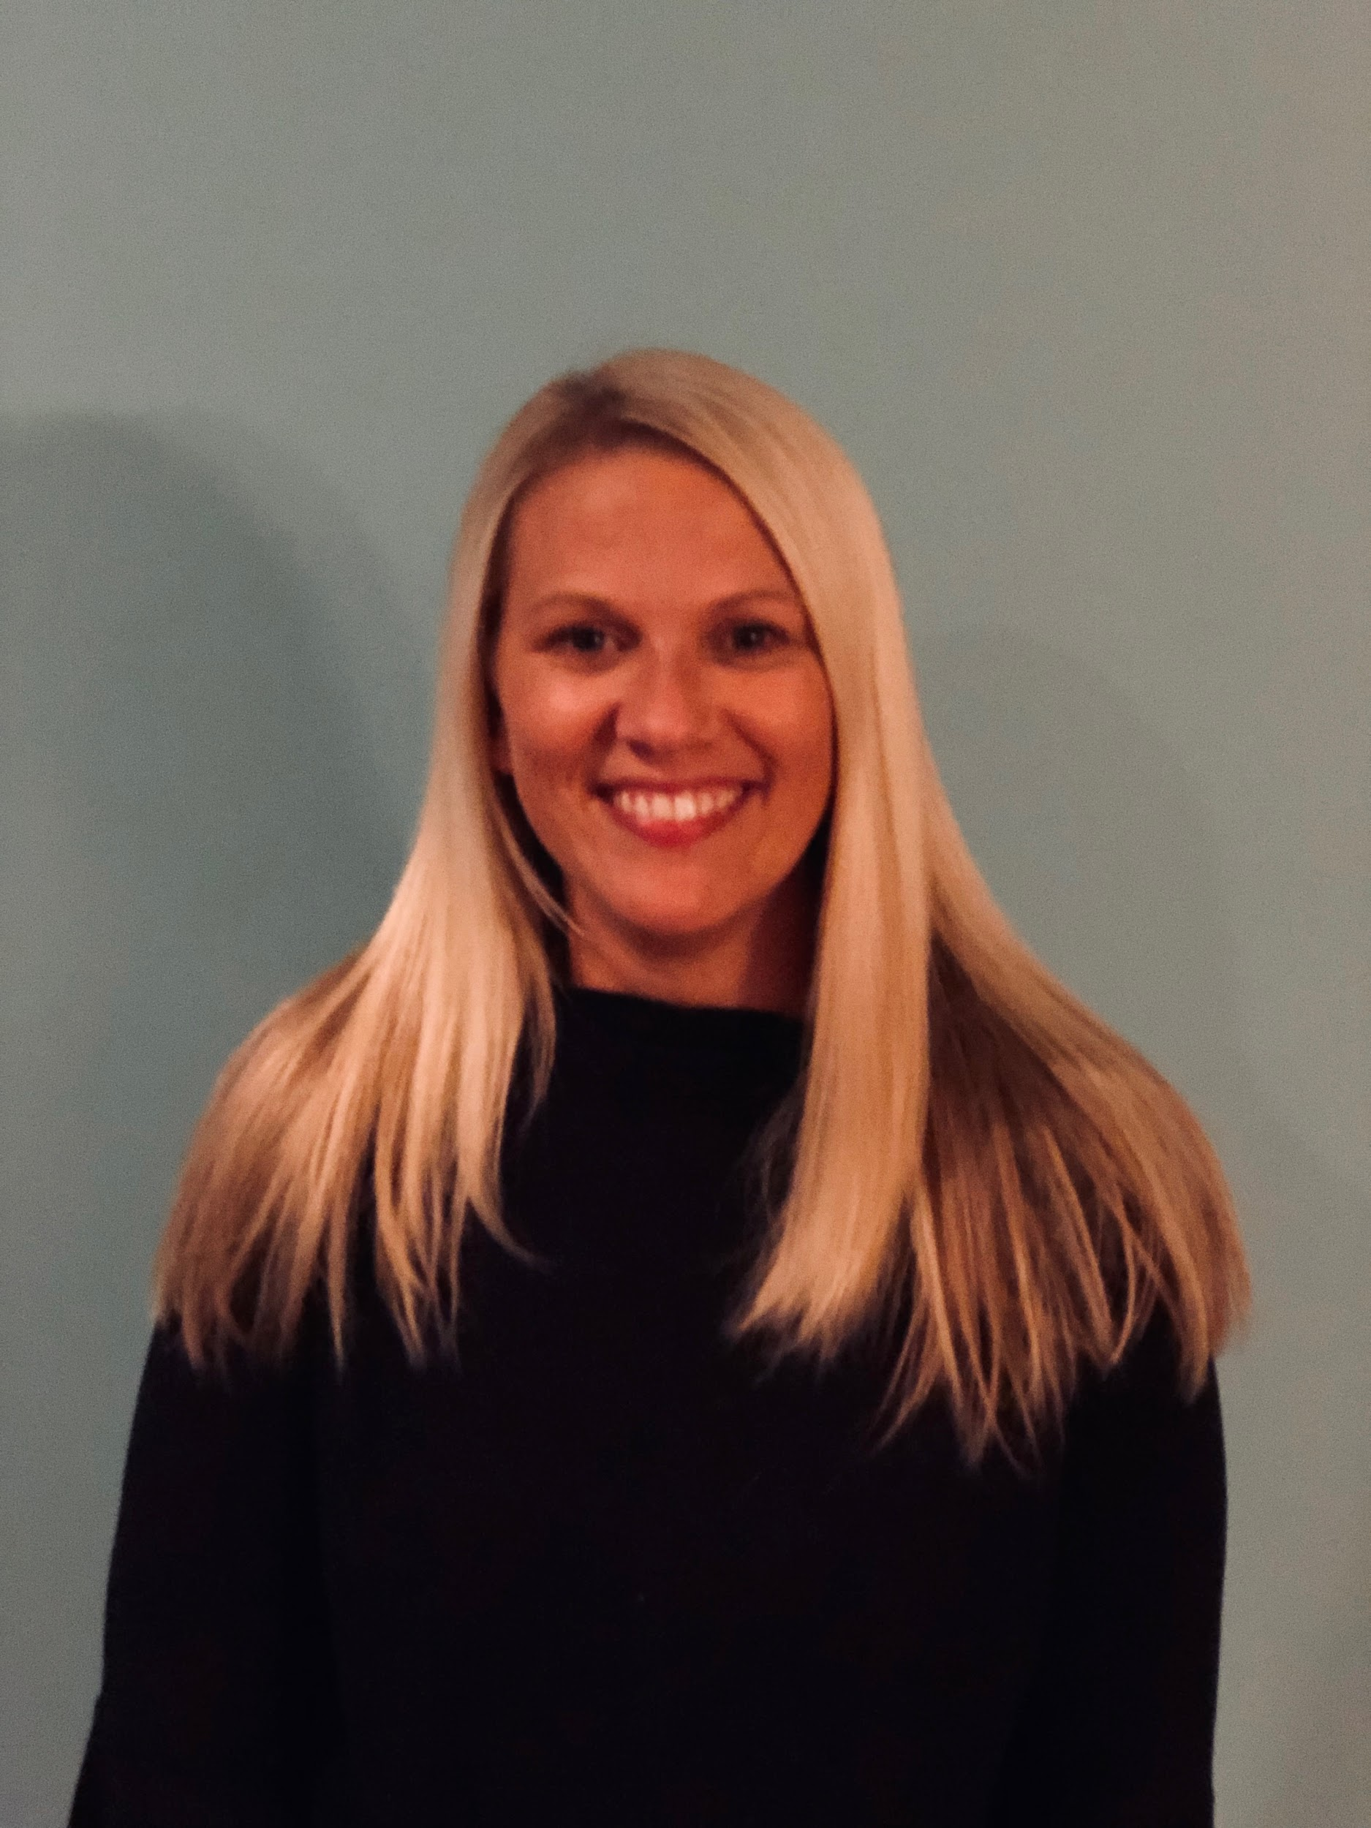
Meet Mrs. James - K-2 Team Teacher & Reading Department Chair K-5

Here is my video!
Hello! My name is Krista James and I am so excited to be a part of your academic journey at CASC. I am so happy to be teaching 2nd grade ELA. I live in Summerville, SC with my husband and sweet little girl. This is my second school year with Cyber Academy and my 11th year of teaching! In addition to second grade, I have taught Prek-1st grade and Reading Intervention. I graduated from Ohio University where I studied Early Childhood Education. A few years later, I received a Master’s degree in reading from National University. Reading is my passion and I love watching my students flourish into amazing, confident readers by the end of the school year! A few of my favorite things are: Mexican food, taking trips to Disney World, exercising, and spending time at the beach. I am so excited to start learning and growing with you this school year! Please feel free to email me anytime with questions or concerns. I will always be here to support you and your child!

Meet Mrs. Calixte- K-2 Team Teacher
Here is my video!
Hello! My name is Dana Calixte and I am so happy to be a part of the CASC family. I am thrilled to be teaching 2nd grade Math. It is my passion to make learning fun though creating an encouraging environment and to develop students to be lifelong learners.

Together we will make positive memories that we will both cherish.
This is my second year at CASC, but it is my ninth-year teaching. I attended The University of Tampa where I studied Elementary Education and English as a Second Language. I have had the honor to teach both national and international students. My teaching experience includes working with students in grades K-5, as well as approaching university students.
I live in Summerville, SC with my husband and my sweet baby girl. When I am not teaching you can find me spending time with my family, traveling, creating healthy recipes, instructing Zumba, and enjoying the outdoors. Not only do I love teaching, but I also love learning. I am currently studying Holistic Nutrition.
I truly look forward to working alongside both students and learning coaches to provide ongoing support throughout the learning journey. Always feel free to email me with any questions or concerns.

Special Education Teacher K-2
Shannon Cunningham - Watch my Welcome Video here!

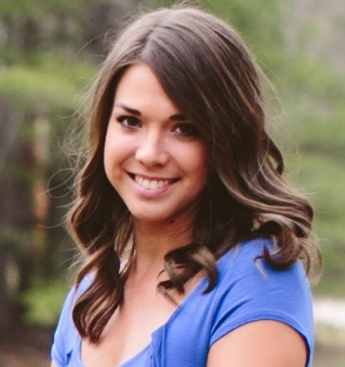

Hi! My name is Shannon Cunningham and I am excited to be the K-2 special education teacher at CASC. I received my undergraduate degree in early childhood/elementary education from Anderson University and my graduate degree in special education from Clemson University. I live in Easley with my precious 6-year-old foster daughter and my husband, Andrew. We hope to adopt very soon! I enjoy hiking and rock climbing in the mountains and water sports at the lake. I have taught the last 9 years in Kindergarten, 1st Grade, and Preschool Special Education in a brick and mortar setting. This will be my first year teaching with CASC and I am looking forward to getting to know you and your child this year as we embark on this journey together.

